IDL Destripe module 31 march 2009

Usage:
destripe, type [,bands=bandslist][,neighbor=band][,/stats]

With:
Type | Required | The algorithm (1, 2, 3, see below)
Bands | Optional | The list of bands to be destriped
Neighbor | Required for type=3 | The band to get the statistics from
Stats | Optional | Write statistics to file

If the bands keyword is left out, all bands will be processed.
The module will ask for an image filename.
The band numbers are 1-based, so can range from [1…#bands]

Examples;
destripe, 2 | Destripe all bands in the image with formula [2]
destripe, 2, bands=4 | Only destripe band 4 in the image with formula [2]
destripe, 1, bands=[4, 5, 19] | Only destripe bands 4, 5, 19 in the image with formula [1]
destripe, 3, neighbor=4 | Destripe all bands with formula [3] using band 4 for stats
Destripe, 3, neighbor=4,/stats | Destripe with formula [3], stats band 4 and write statistics

The output file name is calculated from the input file name:
Output name = <input name>_out_<type>

Similar for the statistics:
Band stat name = <input name>_bandstat_<type>.csv
Column stats name = <input name>_colstats_<type>.csv
The statistics are stored in text table files that can be opened in f.e. Excel directly.

Example: input file = “try_”, algorithm = 3
Output file | try__out_3
Bandstat file | try__bandstat_3.csv
Colstats file | try__colstats_3.csv

The algorithms:
From 196 unique bands in Hyperion image, about 28 bands are severely influenced by vertical strips. For removing the stripe from the image bands the following algorithm can be used:
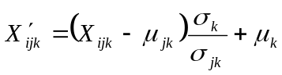 [1]
Or
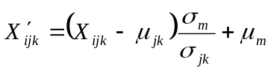 [2]
Or
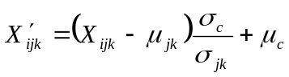 [3]
where 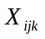 is the pixel value in (row,col)=(i, j) in band k, 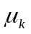and 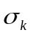 are mean and standard deviation (Std) of the band k, 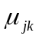 and 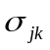 are the mean and Std of column j band k, 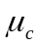and 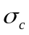 are mean and standard deviation (Std) of the neighboring band which is used for de-striping, 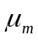and 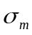 are mean and Std of the image, and 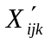 is the calculated pixel value in (row,col)=(i, j) in band k.

So, in simple word, all the pixels in each column of the band to correct should be replaced by new pixel values computed from above equations. The new pixel values of band k are calculated based on mean and standard deviation of the column (where pixel belong to) and for
Equation 1: uses the mean and standard deviation of the band to correct
Equation 2: uses the mean and standard deviation of the entire image
Equation 3: uses the mean and standard deviation of the selected band

Statistic files format:
The band statistics file contains 5 columns:
Destripe | band being destriped
Type | algorithm used
Src_band | source band used for destriping (-1 for entire image)
Mean | mean of the band/image
Stddev | standard deviation of the band/image

There is one records containing the mean / stddev of the band(s) used for the correction: the band itself (type=1), the entire image (type=2; src_band = -1), the neighbor band (type=3)

The columns statistics file contains 4 columns:
Destripe | band being destriped
Column | column number in the band being destriped
Mean | mean of the column
Stddev | standard deviation of the column

There will be records for all band/column combinations

